About Us

Cyinov Consulting: Transforming Business Landscapes Through Strategic Excellence

At Cyinov Consulting, we are dedicated to redefining business consulting by offering comprehensive solutions that bridge the gap between vision and execution. Founded in 2025, we've established ourselves as a dynamic force in the consulting industry, combining innovative methodologies with deep industry expertise to deliver exceptional results for our clients.

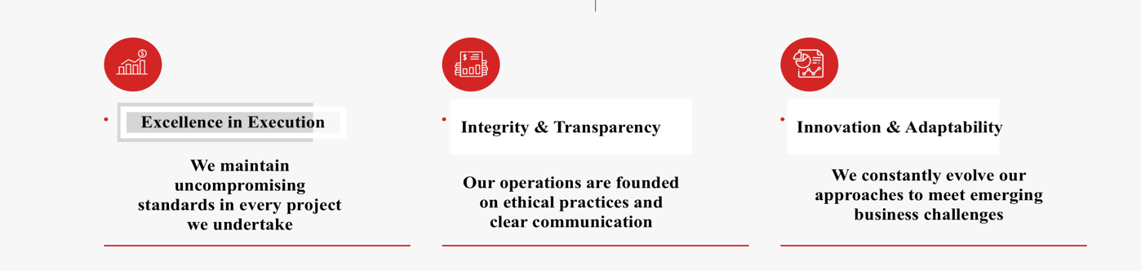

Our Mission To revolutionize business consulting by providing integrated, technology-driven solutions that enable organizations to thrive in a rapidly evolving business landscape while maintaining the highest standards of compliance and operational excellence.

Our Vision To be the most trusted and innovative consulting partner for businesses across sectors, known for our transformative solutions and commitment to client success.

* Excellence in Execution: We maintain uncompromising standards in every project we undertake
* Integrity & Transparency: Our operations are founded on ethical practices and clear communication
* Innovation & Adaptability: We constantly evolve our approaches to meet emerging business challenges
* Client-Centric Focus: Your success metrics are our primary objectives
* Collaborative Growth: We believe in growing together with our clients and stakeholder  
    
  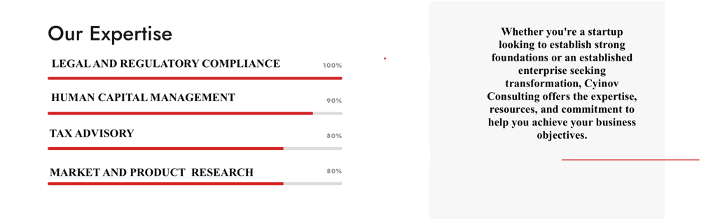

20+ CLIENTS 5+ Clients this month 50 New Projects

Our Approach

* Diagnostic Assessment: We begin with a thorough analysis of your business environment
* Custom Solution Design: Tailored strategies aligned with your specific business objectives
* Implementation Support: Hands-on assistance throughout the execution phase
* Monitoring & Optimization: Continuous performance tracking and improvement
* Knowledge Transfer: Building internal capabilities within your organization

Technology Integration We leverage cutting-edge technologies to enhance our service delivery:

* Advanced Analytics Platforms
* Cloud-based Compliance Management Systems
* Automated Tax Calculation Tools
* Digital HR Management Solutions
* Real-time Reporting Dashboards

Industry Expertise Our consultants bring deep domain knowledge across various sectors:

* Manufacturing and Industrial
* Technology and Software
* Healthcare and Pharmaceuticals
* Retail and E-commerce
* Financial Services
* Real Estate and Infrastructure
* Education and Training

Client Success Commitment

* Dedicated Account Managers
* 24/7 Support System
* Regular Progress Reviews
* Quarterly Strategy Sessions
* Annual Performance Assessments

Quality Assurance Our quality management system ensures:

* Rigorous Quality Control Processes
* Regular Service Audits
* Client Feedback Integration
* Continuous Service Enhancement
* Professional Standards Compliance

Global Best Practices We incorporate international standards and best practices:

* ISO-aligned Processes
* Industry-specific Frameworks
* Global Compliance Standards
* Sustainable Business Practices

Why Partner with Cyinov Consulting?

1. Integrated Solutions Hub
   * Single point of contact for all business needs
   * Seamless coordination across service verticals
   * Consistent quality standards across services
2. Expert Team
   * Experienced Professionals
   * Continuous Learning and Development
   * Industry-specific Expertise
3. Client-Centric Approach
   * Customized Solution Design
   * Flexible Engagement Models
   * Transparent Communication
4. Innovation Focus
   * Regular Methodology Updates
   * Technology Integration
   * Process Optimization
5. Value Addition
   * Cost-Effective Solutions
   * Measurable Outcomes
   * Long-term Partnership Focus

Future Ready As we continue to grow, we remain committed to:

* Expanding our service portfolio
* Strengthening technological capabilities
* Enhancing delivery mechanisms
* Building stronger client relationships
* Contributing to sustainable business practices

Connect with Us

